<https://www.digitalocean.com/community/tutorials/how-to-access-elements-in-the-dom>

How To Access Elements in the DOM

Posted November 20, 2017  166.1k

[JAVASCRIPT](https://www.digitalocean.com/community/tags/javascript?type=tutorials)

[DEVELOPMENT](https://www.digitalocean.com/community/tags/development?type=tutorials)

By [Tania Rascia](https://www.digitalocean.com/community/users/taniarascia) [Become an author](https://www.digitalocean.com/community/write-for-digitalocean)

## Introduction

In [Understanding the DOM Tree and Nodes](https://www.digitalocean.com/community/tutorials/understanding-the-dom-tree-and-nodes), we went over how the DOM is structured as a tree of objects called nodes, and that nodes can be text, comments, or elements. Usually when we access content in the DOM, it will be through an HTML element node.

 ~~In order to be proficient at accessing elements in the DOM, it is necessary to h~~ave a working knSoigwnluepdfgoreouorfnCewSsSletsteer.leGcettothres,lastyensttatuxtoarniadls otenrSmysinAodmloign yanadsowpeenllsaosuracne tuonpdices.rstanding of HTSMC RLOeLleLmT eOnTtsO.PIn

×

~~<~~**~~body~~**~~>~~

Sign up for our newsletter. Get the latest tutorials on SysAdmin and open source topics.

×



[Understanding the DOM — Document Object Model](https://www.digitalocean.com/community/tutorial_series/understanding-the-dom-document-object-model) How To Access Elements in the …

## Overview

this tutorial, we will go over several ways to access elements in the DOM: by ID, class, tag, and query

selectors.

Here is a table overview of the five methods we will cover in this tutorial.

|  |  |  |
| --- | --- | --- |
| Gets Selector Syntax Method | | |
| ID | #demo | getElementById() |
| Class | .demo | getElementsByClassName() |
| Tag | demo | getElementsByTagName() |
| Selector (single) |  | querySelector() |
| Selector (all) |  | querySelectorAll() |

It is important when studying the DOM to type the examples on your own computer to ensure that you are understanding and retaining the information you learn.

You can save this HTML file, access.html , to your own project to work through the examples along [with this article. If you are unsure how to work with JavaScript and HTML locally, review our How To Add JavaScript to HTML tutorial.](https://www.digitalocean.com/community/tutorials/how-to-add-javascript-to-html)

access.html

<!DOCTYPE html>

<**html** lang="en">

<**head**>

<**meta** charset="utf-8">

<**meta** name="viewport" content="width=device-width, initial-scale=1.0">

<**title**>Accessing Elements in the DOM</**title**>

<**style**>

**html** { font-family: sans-serif; color: #333; }

**body** { max-width: 500px; margin: 0 auto; padding: 0 15px; }

**div**, **article** { padding: 10px; margin: 5px; border: 1px solid #dedede; }

</**style**>

</**head**>

SCROLL TO TOP



[Understanding the DOM — Document Object Model](https://www.digitalocean.com/community/tutorial_series/understanding-the-dom-document-object-model) How To Access Elements in the …

<**h2**>Class (.demo)</**h2**>

<**h2**>ID (#demo)</**h2**>

<**div** id="demo">Access me by ID</**div**>

<**div** class="demo">Access me by class (1)</**div**>

<**div** class="demo">Access me by class (2)</**div**>

<**h2**>Tag (article)</**h2**>

<**article**>Access me by tag (1)</**article**>

<**article**>Access me by tag (2)</**article**>

<**h2**>Query Selector</**h2**>

<**div** id="demo-query">Access me by query</**div**>

<**h2**>Query Selector All</**h2**>

<**div** class="demo-query-all">Access me by query all (1)</**div**>

<**div** class="demo-query-all">Access me by query all (2)</**div**>

</**body**>

</**html**>

In this HTML file, we have many elements that we will access with different document methods. When we render the file in a browser, it will look similar to this:

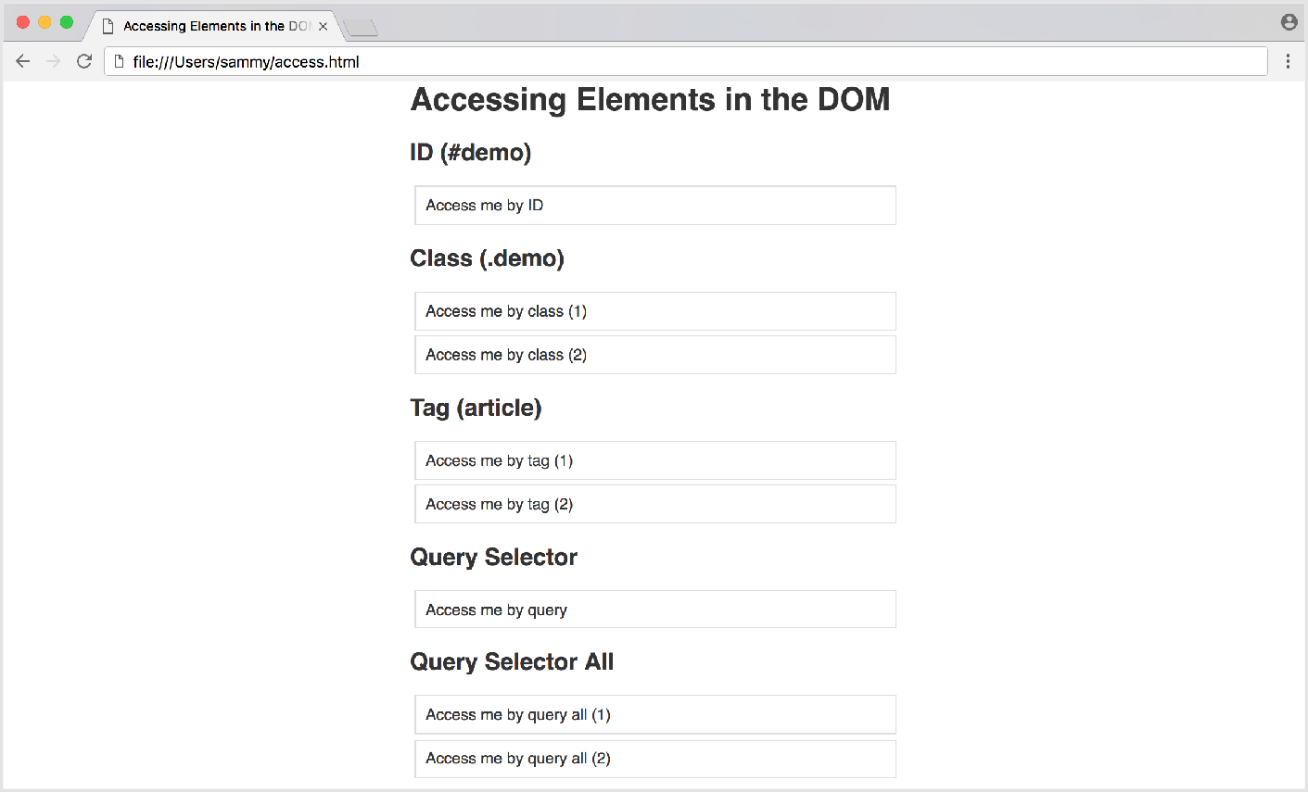

Sign up for our newsletter. Get the latest tutorials on SysAdmin and open source topics.

×

SCROLL TO TOP

Enter your email address Sign Up



[Understanding the DOM — Document Object Model](https://www.digitalocean.com/community/tutorial_series/understanding-the-dom-document-object-model) How To Access Elements in the …

## Accessing Elements by ID

We'll be using the different methods that we outlined in the Overview above to access the available

elements in the file.

The easiest way to access a single element in the DOM is by its unique [ID](https://developer.mozilla.org/en-US/docs/Web/API/Element/id). We can grab an element by

ID with the method of the document object.

[getElementById()](https://developer.mozilla.org/en-US/docs/Web/API/Document/getElementById)

document.getElementById();

In order to be accessed by ID, the HTML element must have an id attribute. We have a div element with an ID of demo .

<**div** id="demo">Access me by ID</**div**>

In the *Console*, let's get the element and assign it to the demoId variable.

* const demoId = document.getElementById('demo');

Logging demoId to the console will return our entire HTML element.

* console.log(demoId);

Output

<div id="demo">Access me by ID</div>

We can be sure we're accessing the correct element by changing the border property to purple .

* demoId.style.border = '1px solid purple';

Once we do so, our live page will look like this:

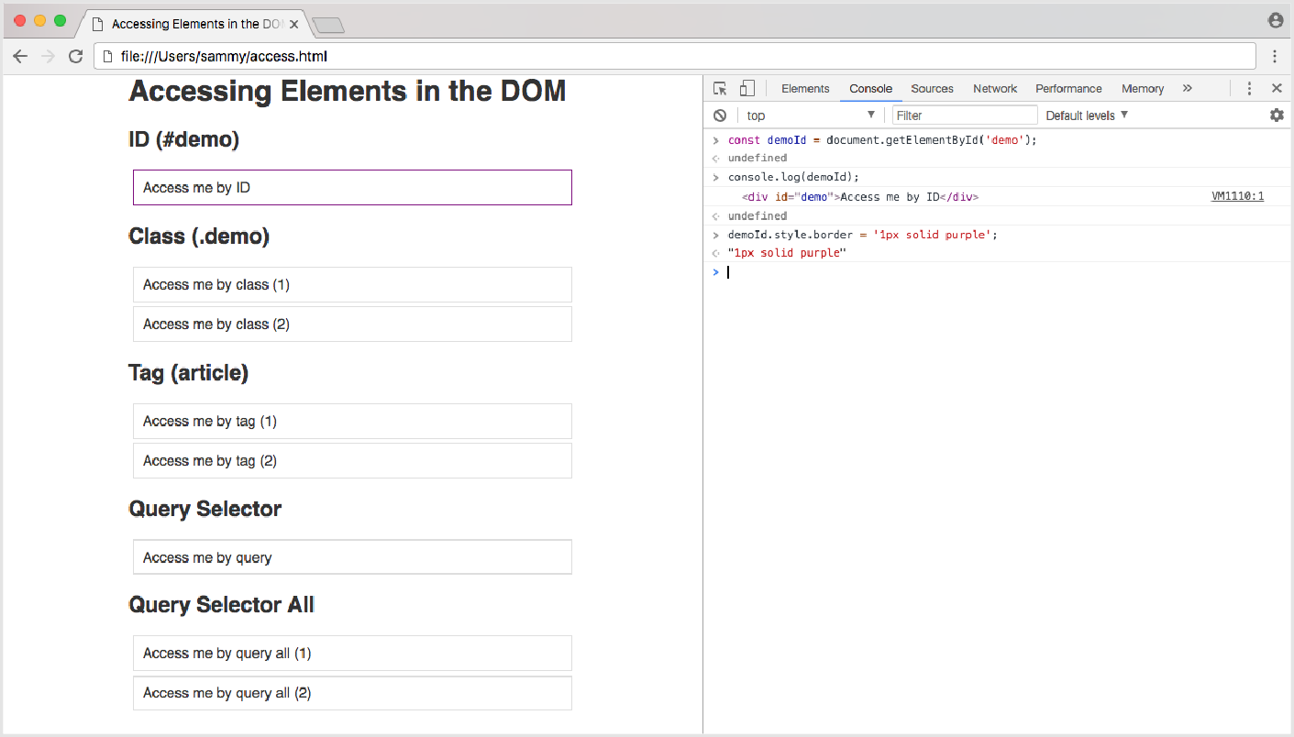

[Understanding the DOM — Document Object Model](https://www.digitalocean.com/community/tutorial_series/understanding-the-dom-document-object-model)

How To Access Elements in the …

Accessing an element by ID is an effective way to get an element quickly in the DOM. However, it has drawbacks; **an ID must always be unique to the page**, and therefore you will only ever be able to access a single element at a time with the getElementById() method. If you wanted to add a function to many elements throughout the page, your code would quickly become repititious.

## Accessing Elements by Class

The [class](https://developer.mozilla.org/en-US/docs/Web/HTML/Global_attributes/class) attribute is used to access **one or more specific elements** in the DOM. We can get all the

elements with a given class name with the method.

[getElementsByClassName()](https://developer.mozilla.org/en-US/docs/Web/API/Document/getElementsByClassName)

document.getElementsByClassName();

Now we want to access more than one element, and in our example we have two elements with a demo

class.

<**div** class="demo">Access me by class (1)</**div**>

<**div** class="demo">Access me by class (2)</**div**>

Let's access our elements in the *Console* and put them in a variable called demoClass .

~~> const demoClass = document.getElementsByClassName('demo');~~



[Understanding the DOM — Document Object Model](https://www.digitalocean.com/community/tutorial_series/understanding-the-dom-document-object-model) How To Access Elements in the …

* demoClass.style.border = '1px solid orange';

elements to orange, we will get an error.

At this point, you might think you can modify the elements the same way you did with the ID example.

However, if we try to run the following code and change the border property of the class demo

Output

Uncaught TypeError: Cannot set property 'border' of undefined

The reason this doesn't work is because instead of just getting one element, we have an array-like object of elements.

* console.log(demoClass);

Output

(2) [div.demo, div.demo]

[JavaScript arrays](https://www.digitalocean.com/community/tutorials/understanding-arrays-in-javascript) must be accessed with an index number. We can therefore change the first element of this array by using an index of 0 .

* **demoClass[0]**.style.border = '1px solid orange';

Generally when accessing elements by class, we want to apply a change to all the elements in the document with that particular class, not just one. We can do this by creating a for loop, and looping through every item in the array.

* for (i = 0; i < demoClass.length; i++) {
* demoClass[i].style.border = '1px solid orange';
* }

When we run this code, our live page will be rendered like this:

We have now selected every element on the page that has a demo class, and changed the border

property to orange .

## Accessing Elements by Tag

A less specific way to access multiple elements on the page would be by its HTML tag name. We

access an element by tag with the method.

[getElementsByTagName()](https://developer.mozilla.org/en-US/docs/Web/API/Element/getElementsByTagName)

document.getElementsByTagName();

For our tag example, we're using article elements.

<article>Access me by tag (1)</article>

<article>Access me by tag (2)</article>

Just like accessing an element by its class, getElementsByTagName() will return an array-like object of elements, and we can modify every tag in the document with a for loop.

* const demoTag = document.getElementsByTagName('article');

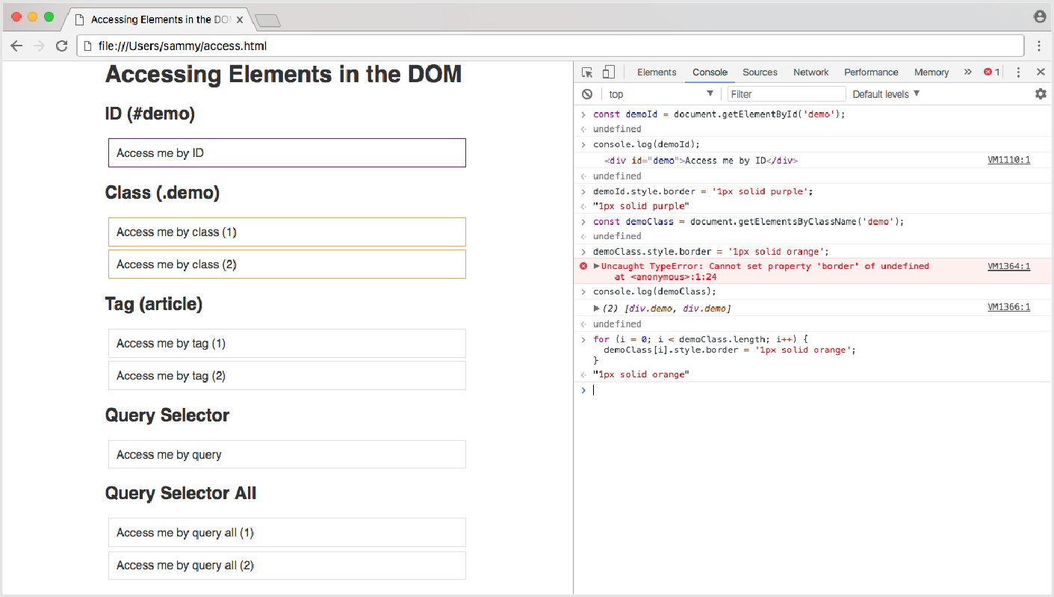

[Understanding the DOM — Document Object Model](https://www.digitalocean.com/community/tutorial_series/understanding-the-dom-document-object-model)

How To Access Elements in the …

>

* for (i = 0; i < demoTag.length; i++) {
* demoTag[i].style.border = '1px solid blue';

×

Sign up for our newsletter. Get the latest tutorials on SysAdmin and open source topics.

* }

SCROLL TO TOP

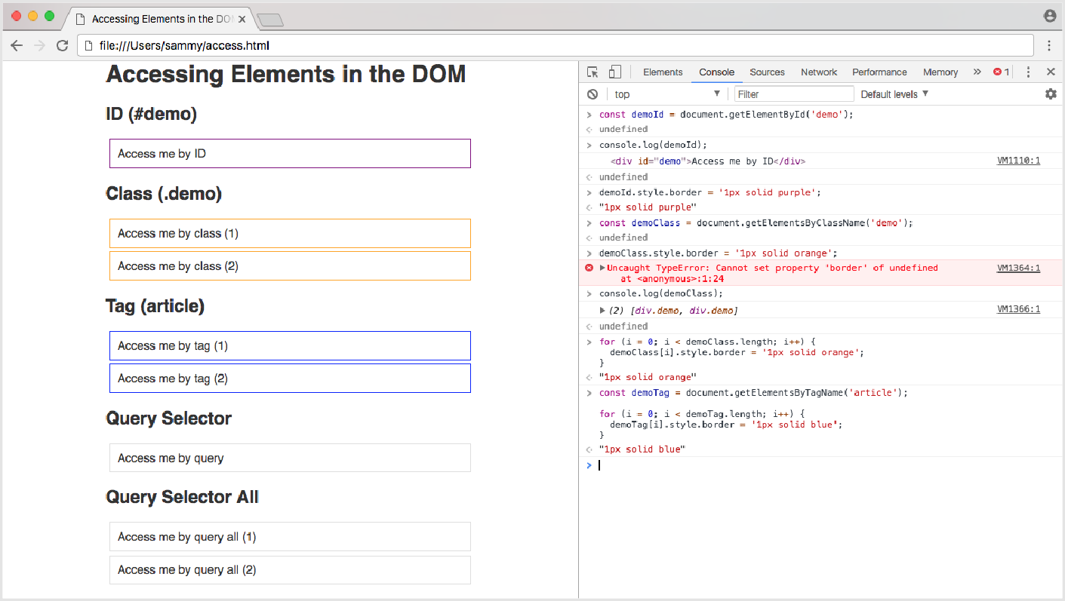

[Understanding the DOM — Document Object Model](https://www.digitalocean.com/community/tutorial_series/understanding-the-dom-document-object-model)

How To Access Elements in the …

The loop changed the border property of all article elements to blue .

## Query Selectors

If you have any experience with the [jQuery](https://jquery.com/) API, you may be familiar with jQuery's method of accessing the DOM with CSS selectors.

$('#demo'); // returns the demo ID element in jQuery

We can do the same in plain JavaScript with the querySelector() and querySelectorAll()

methods.

document.querySelector(); document.querySelectorAll();

To access a single element, we will use the

Upon running the code, the live page will be modified like so:

[querySelector()](https://developer.mozilla.org/en-US/docs/Web/API/Document/querySelector)

demo-query element

<**div** id="demo-query">Access me by query</**div**>

method. In our HTML file, we have a



[Understanding the DOM — Document Object Model](https://www.digitalocean.com/community/tutorial_series/understanding-the-dom-document-object-model) How To Access Elements in the …

* const demoQuery = document.querySelector('#demo-query');

The selector for an [id](https://www.digitalocean.com/community/tutorial_series/understanding-the-dom-document-object-model) attribute is the hash symbol ( # ). We can assign the element with the demo-

query id to the demoQuery variable.

In the case of a selector with multiple elements, such as a class or a tag, querySelector() will return the first element that matches the query. We can use the [querySelectorAll()](https://developer.mozilla.org/en-US/docs/Web/API/Document/querySelectorAll) method to collect all the elements that match a specific query.

In our example file, we have two elements with the demo-query-all class applied to them.

<**div** class="demo-query-all">Access me by query all (1)</**div**>

<**div** class="demo-query-all">Access me by query all (2)</**div**>

The selector for a class attribute is a period or full stop ( . ), so we can access the class with .demo- query-all .

* const demoQueryAll = document.querySelectorAll('.demo-query-all');

Using the forEach() method, we can apply the color green to the border property of all matching elements.

* demoQueryAll.forEach(query => {
* query.style.border = '1px solid green';
* });

With querySelector() , comma-separated values function as an OR operator. For example, querySelector('div, article') will match div *or* article , whichever appears first in the document. With querySelectorAll() , comma-separated values function as an AND operator, and querySelectorAll('div, article') will match all div *and* article values in the document.

Using the query selector methods is extremely powerful, as you can access any element or group of elements in the DOM the same way you would in a CSS file. For a complete list of selectors, review [CSS Selectors](https://developer.mozilla.org/en-US/docs/Web/CSS/CSS_Selectors) on the Mozilla Developer Network.

## Complete JavaScript Code

Below is the complete script of the work we did above. You can use it to access all the elements on our example page. Save the file as access.js and load it in to the HTML file right before the closing body tag.

access.js

// Assign all elements

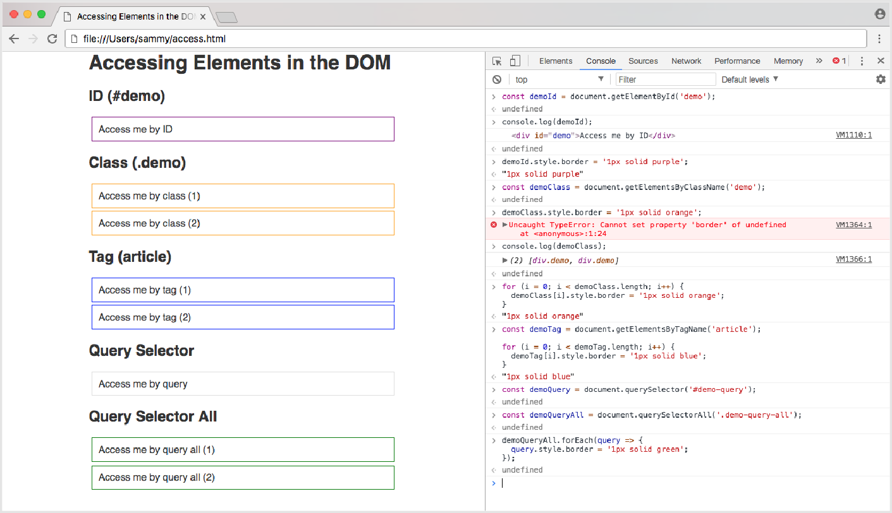

[Understanding the DOM — Document Object Model](https://www.digitalocean.com/community/tutorial_series/understanding-the-dom-document-object-model)

How To Access Elements in the …

**const** demoId = document.getElementById('demo');

**const** demoClass = document.getElementsByClassName('demo'); **const** demoTag = document.getElementsByTagName('article'); **const** demoQuery = document.querySelector('#demo-query');

**const** demoQueryAll = document.querySelectorAll('.demo-query-all');

×

Sign up for our newsletter. Get the latest tutorials on SysAdmin and open source topics.

// Change border of ID demo to purple

SCROLL TO TOP

// Change border of class demo to orange

**for** (i = 0; i < demoClass.length; i++) {



[Understanding the DOM — Document Object Model](https://www.digitalocean.com/community/tutorial_series/understanding-the-dom-document-object-model) How To Access Elements in the …

demoClass[i].style.border = '1px solid orange';

}

// Change border of tag demo to blue

**for** (i = 0; i < demoTag.length; i++) { demoTag[i].style.border = '1px solid blue';

}

// Change border of ID demo-query to red demoQuery.style.border = '1px solid red';

// Change border of class query-all to green demoQueryAll.forEach(query => {

query.style.border = '1px solid green';

});

Your final HTML file will look like this:

access.html

<!DOCTYPE html>

<**html** lang="en">

<**head**>

<**meta** charset="utf-8">

<**meta** name="viewport" content="width=device-width, initial-scale=1.0">

<**title**>Accessing Elements in the DOM</**title**>

<**style**>

**html** { font-family: sans-serif; color: #333; }

**body** { max-width: 500px; margin: 0 auto; padding: 0 15px; }

**div**, **article** { padding: 10px; margin: 5px; border: 1px solid #dedede; }

</**style**>

</**head**>

<**body**>

<**h1**>Accessing Elements in the DOM</**h1**>

<**h2**>ID (#demo)</**h2**>

<**div** id="demo">Access me by ID</**div**>

×

Sign up for our newsletter. Get the latest tutorials on SysAdmin and open source topics.

<**h2**>Class (.demo)</**h2**>

SCROLL TO TOP



[Understanding the DOM — Document Object Model](https://www.digitalocean.com/community/tutorial_series/understanding-the-dom-document-object-model) How To Access Elements in the …

[UnSidgneurpsftoar onudr nienwgsletthteer. GDetOthMe lat—estDtuotocriaulsmoneSnytsAOdmbijneacntd Mopeondsoeul](https://www.digitalocean.com/community/tutorial_series/understanding-the-dom-document-object-model)rce topics.

×

<**article**>Access me by tag (1)</**article**>

<**div** class="demo">Access me by class (2)</**div**>

<**h2**>Tag (article)</**h2**>

<**article**>Access me by tag (2)</**article**>

<**h2**>Query Selector</**h2**>

<**div** id="demo-query">Access me by query</**div**>

<**h2**>Query Selector All</**h2**>

<**div** class="demo-query-all">Access me by query all (1)</**div**>

<**div** class="demo-query-all">Access me by query all (2)</**div**>

<**script** src="access.js"></**script**>

</**body**>

</**html**>

You can continue to work on these template files to make additional changes by accessing HTML elements.

## Conclusion

In this tutorial, we went over 5 ways to access HTML elements in the DOM — by ID, by class, by HTML tag name, and by selector. The method you will use to get an element or group of elements will depend on browser support and how many elements you will be manipulating. You should now feel confident to access any HTML element in a document with JavaScript through the DOM.

By [Tania Rascia](https://www.digitalocean.com/community/users/taniarascia)

Upvote (21)  Subscribe  Share

Editor: [Lisa Tagliaferri](https://www.digitalocean.com/community/users/ltagliaferri)

Tutorial Series

SCROLL TO TOP



[Understanding the DOM — Document Object Model](https://www.digitalocean.com/community/tutorial_series/understanding-the-dom-document-object-model) How To Access Elements in the …

### scripting language that connects to the DOM in an internet browser.

manipulate the content, structure, and style of a website. JavaScript is the client-side

[The Document Object Model, usually referr](https://www.digitalocean.com/community/tutorial_series/understanding-the-dom-document-object-model)ed to as the DOM, is an essential part of

making websites interactive. It is an interface that allows a programming language to

Show Tutorials

Related Tutorials

[How To Build a Search Bar with RxJS](https://www.digitalocean.com/community/tutorials/how-to-build-a-search-bar-with-rxjs)

[How To Build a Weather App with Angular, Bootstrap, and the APIXU API](https://www.digitalocean.com/community/tutorials/how-to-build-a-weather-app-with-angular-bootstrap-and-the-apixu-api) [How To Build a Blog with Nest.js, MongoDB, and Vue.js](https://www.digitalocean.com/community/tutorials/how-to-build-a-blog-with-nest-js-mongodb-and-vue-js)

[How to Use Node.js and Github Webhooks to Keep Remote Projects in Sync](https://www.digitalocean.com/community/tutorials/how-to-use-node-js-and-github-webhooks-to-keep-remote-projects-in-sync)

[How to Generate a Short and Unique Digital Address for Any Location Using AngularJS and PHP](https://www.digitalocean.com/community/tutorials/how-to-generate-short-unique-digital-address-any-location-angularjs-php)

# 2 Comments

Leave a comment...

[Log In to Comment](https://www.digitalocean.com/community/auth/digitalocean)

[jmarinfotecnico](https://www.digitalocean.com/community/users/jmarinfotecnico) [*March 9, 2019*](https://www.digitalocean.com/community/tutorials/how-to-access-elements-in-the-dom?comment=77848)



0 Great explanation Tania on how to access to DOM elements, I have understood the array idea behind these

×

Sign up for our newsletter. Get the latest tutorials on SysAdmin and open source topics.

types of objects in Javascript.

SCROLL TO TOP



[Understanding the DOM — Document Object Model](https://www.digitalocean.com/community/tutorial_series/understanding-the-dom-document-object-model) How To Access Elements in the …

[paroche](https://www.digitalocean.com/community/users/paroche) [*April 25, 2019*](https://www.digitalocean.com/community/tutorials/how-to-access-elements-in-the-dom?comment=78937)

Thanks to you, I will be able to automate a web page data introduction via Internet Explorer and PowerShell.



0 Hi Tania, I too thought it was a great tutorial -- all of them are so far. Really helpful. There is one thing, though, that I think could be improved. When you are processing elements that were accessed using

.getElementsByClassName, or .getElementsByTagName, you handle the returned variable with a for loop, but when you are processing elements that were accessed using .querySelectorAll you handle the returned variable with the .forEach method. I think it would have been good to have some explanation for why -- which, if I understand correctly, is because the "getElementsBy...()" methods return "HTMLCollection" objects, which cannot be processed with .forEach like arrays, while the querySelectorAll() method returns "NodeList" objects, which, in modern browsers, CAN be processed with .forEach like arrays. I think a little explanation about that would have been helpful.



[This work is licensed under a Creative Commons Attribution-NonCommercial- ShareAlike 4.0 International License.](https://creativecommons.org/licenses/by-nc-sa/4.0/)



[BECOME A CONTRIBUTOR](https://www.digitalocean.com/write-for-donations/)

[You get paid; we donate to tech nonprofits.](https://www.digitalocean.com/write-for-donations/)

Sign up for our newsletter. Get the latest tutorials on SysAdmin and open source topics.

×

SCROLL TO TOP

Enter your email address [Sign Up](https://www.meetup.com/pro/digitalocean)

[Understanding the DOM — Document Object Model](https://www.digitalocean.com/community/tutorial_series/understanding-the-dom-document-object-model) How To Access Elements in th[e …](https://www.meetup.com/pro/digitalocean)



[CONNECT WITH OTHER DEVELOPERS](https://www.meetup.com/pro/digitalocean)

## [Find a DigitalOcean Meetup near you.](https://www.meetup.com/pro/digitalocean)

[GET OUR BIWEEKLY NEWSLETTER](https://www.digitalocean.com/community/newsletter)

## [Sign up for Infrastructure as a Newsletter.](https://www.digitalocean.com/community/newsletter)

Featured on Community [Intro to Kubernetes](https://www.digitalocean.com/community/tutorials/an-introduction-to-kubernetes) [Learn Python 3](https://www.digitalocean.com/community/tutorial_series/how-to-code-in-python-3) [Machine Learning in Python](https://www.digitalocean.com/community/tutorials/machine-learning-projects-python-a-digitalocean-ebook) [Getting started with Go](https://www.digitalocean.com/community/tutorials/how-to-write-your-first-program-in-go) [Migrate Node.js to Kubernetes](https://www.digitalocean.com/community/tutorial_series/from-containers-to-kubernetes-with-node-js)

DigitalOcean Products [Droplets](https://www.digitalocean.com/products/droplets/) [Managed Databases](https://www.digitalocean.com/products/managed-databases/) [Managed Kubernetes](https://www.digitalocean.com/products/kubernetes/) [Spaces Object Storage](https://www.digitalocean.com/products/spaces/)

[Marketplace](https://marketplace.digitalocean.com/)

[Welcome to the developer cloud](https://www.digitalocean.com/products)

## [DigitalOcean makes it simple to launch in the cloud and scale up as you grow – whether you’re running one virtual machine or ten thousand.](https://www.digitalocean.com/products)

[Learn More](https://www.digitalocean.com/products)



Sign up for our newsletter. Get the latest tutorials on SysAdmin and open source topics.

×

SCROLL TO TOP

Enter your email address Sign Up

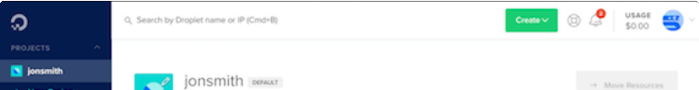

[Understanding the DOM — Document Object Model](https://www.digitalocean.com/community/tutorial_series/understanding-the-dom-document-object-model) How To Access Element[s in the …](https://www.digitalocean.com/products)

Company Products

© 2019 DigitalOcean, LLC. All rights reserved.

[About](https://www.digitalocean.com/about/) [Leadership](https://www.digitalocean.com/about/leadership/) [Blog](https://blog.digitalocean.com/) [Careers](https://www.digitalocean.com/careers/) [Partners](https://www.digitalocean.com/partners/)

[Referral Program](https://www.digitalocean.com/referral-program/) [Press](https://www.digitalocean.com/press/)

[Legal & Security](https://www.digitalocean.com/legal/)

[Products Overview](https://www.digitalocean.com/products/) [Pricing](https://www.digitalocean.com/pricing/)

[Droplets](https://www.digitalocean.com/products/droplets/) [Kubernetes](https://www.digitalocean.com/products/kubernetes/) [Managed Databases](https://www.digitalocean.com/products/managed-databases/) [Spaces](https://www.digitalocean.com/products/spaces/)

[Marketplace](https://www.digitalocean.com/products/marketplace/) [Load Balancers](https://www.digitalocean.com/products/load-balancer/) [Block Storage](https://www.digitalocean.com/products/block-storage/)

[Tools & Integrations](https://www.digitalocean.com/products/tools-and-integrations/) [API](https://developers.digitalocean.com/documentation/)

[Documentation](https://www.digitalocean.com/docs) [Release Notes](https://www.digitalocean.com/docs/release-notes/)

Community

[Tutorials](https://www.digitalocean.com/community/tutorials) [Q&A](https://www.digitalocean.com/community/questions)

[Projects and Integrations](https://www.digitalocean.com/community/projects) [Tags](https://www.digitalocean.com/community/tags)

[Product Ideas](https://ideas.digitalocean.com/) [Meetups](https://www.meetup.com/pro/digitalocean/?utm_source=do_www)

[Write for DOnations](https://www.digitalocean.com/write-for-donations/) [Droplets for Demos](https://www.digitalocean.com/droplets-for-demos/) [Hatch Startup Program](https://www.digitalocean.com/hatch/) [Shop Swag](http://store.digitalocean.com/)

[Research Program](https://www.digitalocean.com/research/) [Currents Research](https://www.digitalocean.com/currents/) [Open Source](https://www.digitalocean.com/open-source/)

Contact

[Support](https://www.digitalocean.com/support/) [Sales](https://www.digitalocean.com/company/contact/sales/)

[Report Abuse](https://www.digitalocean.com/company/contact/#abuse) [System Status](https://status.digitalocean.com/)

SCROLL TO TOP

Sign up for our newsletter. Get the latest tutorials on SysAdmin and open source topics.

×

Enter your email address Sign Up